Format: A4
Margins: Top 3.0cm; Bottom 2.0 cm; Left 2.5 cm; Right 2.5 cm
Title, concise and descriptive - Times New Roman 16 – Bold
A. Author¹, B. Author² and C. Author³ - Times New Roman 11 – Bold – Italics
¹ Author affiliation address - Times New Roman 10 – Italics
² Author affiliation address- Times New Roman 10 – Italics
³ Author affiliation address - Times New Roman 10 – Italics

Everything centred, even address
Abstract - Time new Roman 12, bold

Text: Time new Roman 11
All submissions require an abstract. This should not exceed 400 words.

Key words: Times New Roman 11
Choose up to six key words for indexing
Text in two columns

Introduction - Times New Roman 12 – Bold

Text in 2 columns – Times New Roman 11

New paragraph with 0.5 intend, line spacing 1.15 lines, justified

Materials and Methods
Text in 2 columns – Times New Roman 11

New paragraph with 0.5 intend, line spacing 1.15 lines, justified

Title 2: Times New Roman 11 – Bold – Italics
Text in 2 columns – Times New Roman 11

New paragraph with 0.5 intend, line spacing 1.15 lines, justified

Title 3: Times New Roman 11 – Italics

Text in 2 columns – Times New Roman 11

New paragraph with 0.5 intend, line spacing 1.15 lines, justified
Results & Discussion

Text in 2 columns – Times New Roman 11

New paragraph with 0.5 intend, line spacing 1.15 lines, justified

Table 1. – title above, Times New Roman 10, line spacing single
Possible description under the table Times New Roman 10, line spacing single
Sample data
 | More data
1 | Yes | 1 | 2 | 3 | 4
2 | Yes |  | 2 | 3 | 4
3 | No |  |  | 3 | 4
4 | No |  |  |  | 4

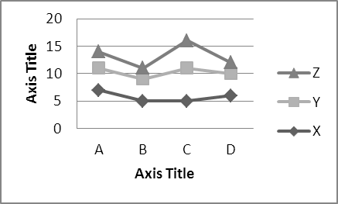
Figure 1. title below, Times New Roman 10, line spacing single

Conclusions
Text in 2 columns – Times New Roman 11

New paragraph with 0.5 intend, line spacing 1.15 lines, justified
Acknowledgments
Text in 2 columns – Times New Roman 11
New paragraph with 0.5 intend, line spacing 1.15 lines, justified

References

Text in 2 columns – Times New Roman 11

New paragraph with 0.5 hanging, line spacing 1.15 lines, justified

Author, N.N, Author, N. and Author N-N. 2019. Title of the paper. Journal Name. 10 (11), 12-23.

